Upload all Assignments Submitted 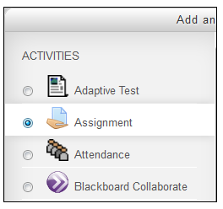
Instructors may choose to give feedback directly on students’ (downloaded) work. Instructors may upload all the students’ feedback files at once in a zipped folder. Each student will receive their feedback file from the instructor when they reopen the assignment. This saves the instructor time.

Contents
- Marking Uploaded Assignments (Steps to ensure you are able to bulk upload marked assignments.)
- Steps to Upload all files submitted by students.
Marking Uploaded Assignments

1. Open the downloaded assignment file on your computer. (Please see directions on how to bulk download assignments uploaded to Moodle by students.)

2. Create a new file for marked work.
3. When you finish giving feedback for a student’s assignment, save the document as a PDF within the marked work file. Do not change the document names.
4. Zip the file. Right click on the File. Click Send to > Compressed (zipped) folder.

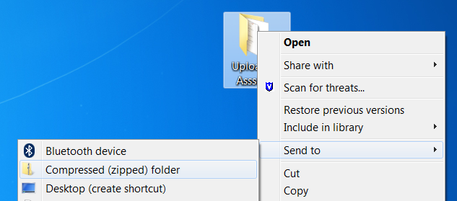

Upload all the Feedback Files
- Go to the course home page.
- Click on the Assignments activities on the course home page.
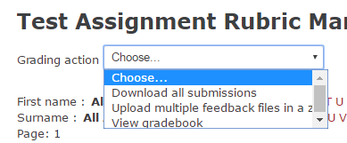
- Click View/grade all submissions.

- Choose Upload multiple feedback files in a zip from Grading action.
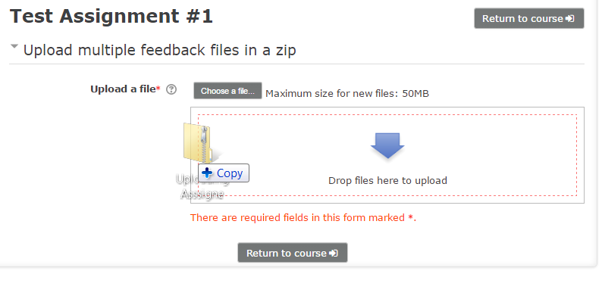
- Upload a zip file by dragging and dropping or clicking the Choose a file button.
Click on the Import feedback file(s) button.

- Click on the Confirm button.
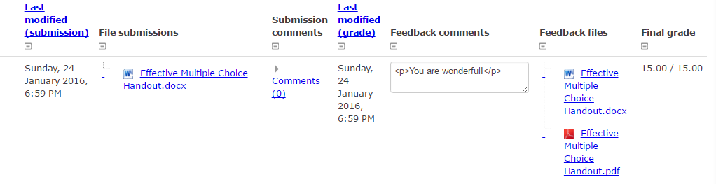
- Click on the Continue button. The feedback files will be allocated to the Feedback files column.

For more information contact Moodle Help.

